联合国危险货物运输标志
  爆炸品  UN Transport symbol for explosives | 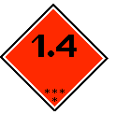  不产生重大危害的爆炸品  UN Transport symbol for Class 1.4 Explosive substances which present no significant hazard | 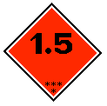  具有大规模爆炸性，但极不敏感的物品  UN Transport symbol for Class 1.5 Very insensitive substances which have a mass explosion hazard
  不燃气体  UN Transport symbol for non-inflammable gases | 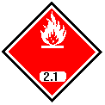  易燃气体  UN Transport symbol for inflammable gases |   易燃气体（第2类）或者易燃液体（第3类）  UN Transport symbol for inflammable gases (Class 2) or liquids (Class 3)
  易燃固体（第4类）  UN Transport symbol for inflammable solids (Class 4) |   遇水释放出易燃气体的物品  UN Transport symbol for substances which, in contact with water, emit inflammable gases | 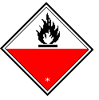  易自燃物品  UN Transport symbol for substances liable to spontaneous combustion
  有毒物品（第2类和第6.1类）  UN Transport symbol for poisonous substances (gases Class 2., other poisonous substances Class 6.1) |   氧化剂和有机过氧化物  UN Transport symbol for oxidizing substances and for organic peroxides |   感染性物品  UN Transport symbol for infectious substances
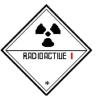  放射性物品（第I级）  UN Transport symbol for radioactive substances, Category I | 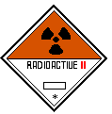  放射性物品（第II级）  UN Transport symbol for radioactive substances, Category II | 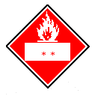  放射性物品（第III级）  UN Transport symbol for radioactive substances, Category III
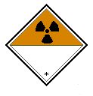  放射性物品 UN Transport symbol for radioactive substances |   腐蚀性物品 UN Transport symbol for corrosive substances | 危险性类别编号的位置：**  Location of serial number: **

